Holy Communion Order of Service

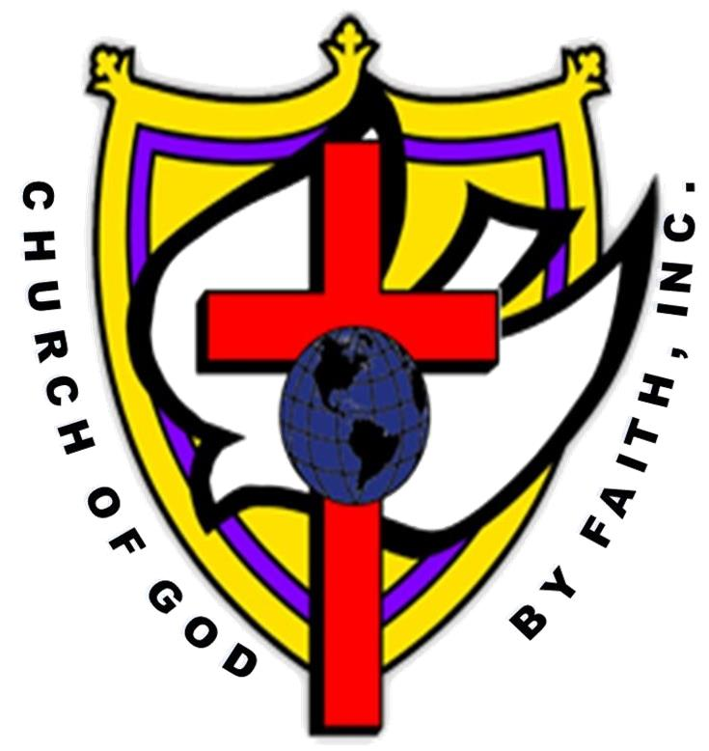

* **Opening Prayer**
* **Praise and Worship**
* **Meet/Greet**
* **Welcome Visitors**
* **Sermonic Hymn**
* **Message**
* **Alter Call/Prayer**

**-----------------------------------------------------------------------------------------**

* **Holy Communion Ceremony** *(No entering or exiting the sanctuary during the ceremony)*

**The Initiation and Invitation**

**Elder reads:**  *We come now to the table knowing that we have an Advocate with the Father, Jesus Christ the righteous and He is the propitiation for our sins; and not for ours only, but for the sins of the whole world.*

*We rejoice in our new life, and are intent on following the Commandments of God and walking from henceforth in His Holy way. Drawn near with faith to take the Holy Sacraments, we devoutly make our humble confession to Almighty God.*

**The Prayer of Confession**

**Elder reads:** *God and Father of our Lord Jesus Christ, Creator of all things and Judge of all men, we acknowledge our sins, which we from time to time have committed by thought, word, and deed against Thee. We do earnestly repent and are heartily sorry for these our misdoings; the remembrance of them is grievous to us. Please Sir, have mercy upon us, most merciful Father; for Thy Son, Our Lord and Savior’s Sake, forgive us all that is past; and grant that we may ever hereafter serve and please Thee in newness of life.*

*We do NOT presume to come to this, Thy Holy table, O gracious God, trusting in our own righteousness; but we come in Thy great mercies. Grant us therefore merciful Lord, as we partake in the Holy Communion of Thy Son Jesus that we may live thereby and that being washed through His most precious Blood and Holy Word, we may evermore dwell in Him and He in us in Christ Jesus our Lord’s Name. Amen*

* **The elder(s) wash his hands using the basin provided by the clergy/designee who also extract the covering.**
* **If candles are used, they should be lit at this point.**
* **Here the elder stretches forth his hands towards the elements and blesses them with these words:**

**Elder reads:** *Almighty God, our Heavenly Father, Who of Thy tender mercies did give us Thine Only Son Jesus Christ to suffer death upon the cross for our redemption; Who made there a full perfect and sufficient sacrifice, and satisfaction for the sins of the whole world; and did institute in His Holy Gospel command us to continue a perpetual memory of His precious death until His eminent return; O merciful Father, we humbly beseech Thee to sanctify these elements of Bread and Fruit of the vine in Thy Son’s Jesus Name. AMEN*

**Elder then reads:** *And when the hour was come, He sat down, and the twelve apostles with Him. And said unto them, with desire I have desired to eat this Passover with you before I suffer: for I say unto you, I will not any more eat thereof until it be fulfilled in the kingdom of God. And He took the cup, and gave thanks, and said, Take this and divide it among yourselves: for I say unto you, I will not drink of the fruit of the vine, until the kingdom of God shall come. And He took bread and gave thanks, and break it, and gave it unto them, saying, this is my Body which is given for you: this do in remembrance of Me. Likewise also He took the cup after supper saying, this cup is the New Testament in My Blood, which is shed for you. For as often as ye eat this bread, and drink this cup, ye do shew the Lord’s death till He come.* (Luke 22:14 – 20; 1 Corinthians 11:26)

* **[Here the clergy shall partake of the Sacrament]**
* **The Distribution of the Sacrament to the body** (songs of Communion)
* **The elder physically handles each component distributing to the clergy or deacon/deaconess whom distributes each to the participants**
* **Those participating in the ceremony are invited to come while following the directions of the ushers beginning from the rear. Everyone receives their elements and return to their seats and remain standing until everyone has been served.**
* **The Administration of the Sacrament**

**Elder reads:** *The Body of our Lord Jesus Christ, which was given for thee, preserves thy soul and body unto everlasting life. Take and eat this in remembrance that Christ died for thee and feed on Him in thy heart by faith, with thanksgiving.*

**Elder reads:** *The Blood of our Lord Jesus Christ, which was shed for thee, preserve thy soul and body unto everlasting life. Drink this in remembrance of that Christ’s blood was shed for thee and be thankful.*

* **The Lord’s Prayer: Sung by designee or recorded music**
* **Prayer of Thanksgiving: By Designee**
* **Worship through Giving (Offering)**
* **Announcements/Dismissal**